**Summary of skewness & kurtosis:**

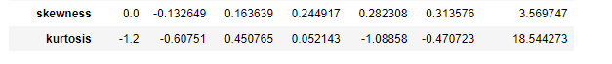

**Skewness:**

The dataset indicates that students' SSC pass marks exhibit a negative skewness of -0.133, whereas HSC, degree, E-test, and MBA grades show positive skewness (0.163, 0.244, 0.282, 0.313).

Additionally, the placement salary distribution is positively skewed with a value of 3.570.

**Kurtosis:**

Regarding kurtosis, the marks in SSC, HSC, degree, E-test, and MBA have kurtosis values of -0.60, 0.45, 0.05, -1.08, and -0.47, respectively.

These values suggest platykurtic distributions with low kurtosis (thin tails).

Conversely, the salary distribution has a kurtosis of 18.54, indicating a leptokurtic distribution with high kurtosis (fat tails).